LAB EXPERIMENT
SET 18: PRODUCT INVENTORY MANAGEMENT
Department | AIDS
Course Code / Course Name | DSA0602 / Data Handling and Visualization
Experiment | Data Visualization using R and Tableau
Name | D.HEMASREE
Register Number | 192524114
Date | 10 October 2026
Day | Saturday
Aim
To analyze product inventory data using a bar chart, a stacked bar chart and an inventory table in R, and to build an interactive dashboard using Tableau. Dataset: Product Inventory
Product ID | Product Name | Quantity Available | Price (in $)
1 | Product A | 250 | 20
2 | Product B | 175 | 15
3 | Product C | 300 | 18
PROGRAM 1: Bar Chart of Product Quantities
Create a bar chart to visualize the quantity of each product in the inventory. Label the axes and title the chart.
inventory <- data.frame(
Product_ID = 1:3,
Product_Name = c("Product A", "Product B", "Product C"),
Quantity_Available = c(250, 175, 300),
Price = c(20, 15, 18)
)

bp <- barplot(inventory$Quantity_Available,
names.arg = inventory$Product_Name,
col = c("steelblue", "darkorange", "forestgreen"),
xlab = "Product",
ylab = "Quantity Available",
main = "Quantity of Each Product in Inventory",
ylim = c(0, 350))
text(bp, inventory$Quantity_Available,
labels = inventory$Quantity_Available, pos = 3)

OUTPUT:
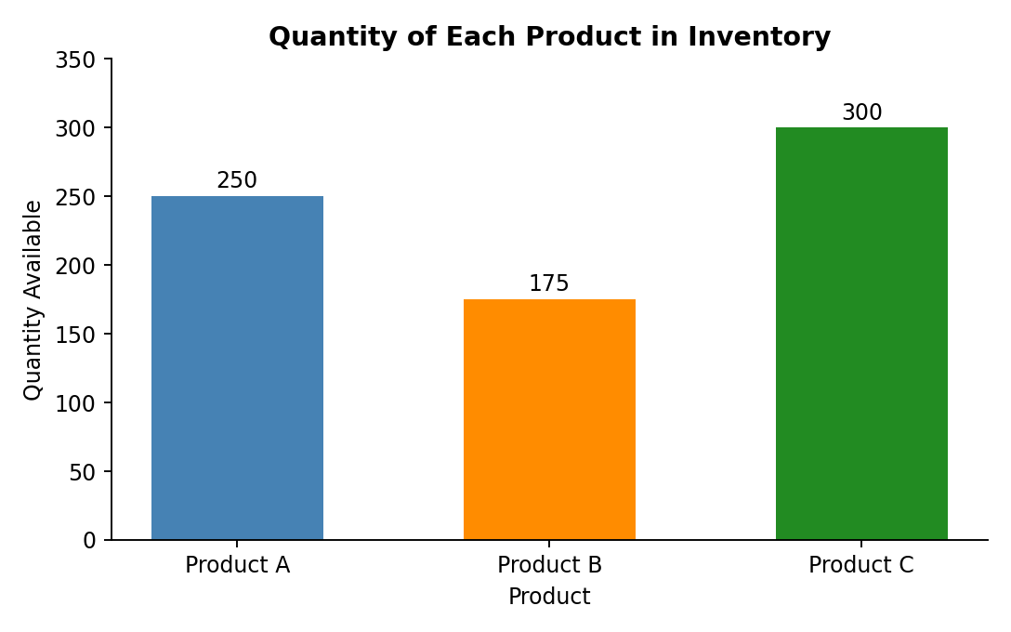
Output 1: Quantity of Each Product in Inventory (Bar Chart)
Observation: Product C has the largest stock at 300 units, followed by Product A with 250 and Product B with 175. Product B has the lowest quantity, about 42% less than Product C. The inventory holds 725 units in total, of which Product C is about 41.4%, Product A about 34.5% and Product B about 24.1%.
PROGRAM 2: Stacked Bar Chart of Quantity by Category
Generate a stacked bar chart to show the quantity of each product within different product categories.
The dataset has no category column, so a sample category is assigned to each product: Product A and Product C in Category 1, and Product B in Category 2.
library(ggplot2)

inventory <- data.frame(
Product_ID = 1:3,
Product_Name = c("Product A", "Product B", "Product C"),
Quantity_Available = c(250, 175, 300),
Price = c(20, 15, 18)
)

inventory$Category <- c("Category 1", "Category 2", "Category 1")

ggplot(inventory,
aes(x = Category, y = Quantity_Available, fill = Product_Name)) +
geom_col(width = 0.5) +
geom_text(aes(label = Quantity_Available),
position = position_stack(vjust = 0.5), color = "white") +
scale_fill_manual(values = c("Product A" = "steelblue",
"Product B" = "darkorange",
"Product C" = "forestgreen")) +
labs(title = "Quantity of Products by Category",
x = "Product Category",
y = "Quantity Available",
fill = "Product")

OUTPUT:
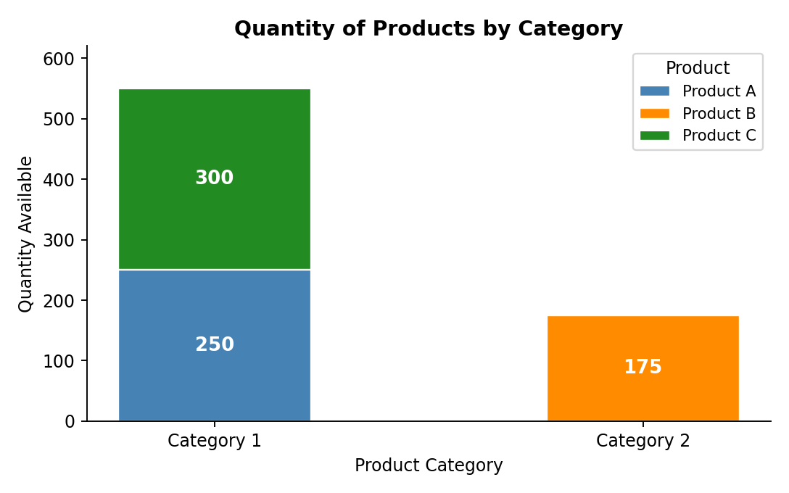
Output 2: Quantity of Products by Category (Stacked Bar Chart)
Observation: Category 1 holds 550 units (Product A 250 and Product C 300), about 75.9% of the inventory, while Category 2 holds the 175 units of Product B (about 24.1%). Within Category 1, Product C contributes the larger share.
PROGRAM 3: Table of Inventory Data for Each Product
Build a table to show the inventory data for each product. Label the table elements.
inventory <- data.frame(
Product_ID = 1:3,
Product_Name = c("Product A", "Product B", "Product C"),
Quantity_Available = c(250, 175, 300),
Price = c(20, 15, 18)
)

inventory$Inventory_Value <- inventory$Quantity_Available * inventory$Price

print(inventory)

colSums(inventory[, c("Quantity_Available", "Inventory_Value")])

OUTPUT:
Console Output
Product_ID Product_Name Quantity_Available Price Inventory_Value
1 1 Product A 250 20 5000
2 2 Product B 175 15 2625
3 3 Product C 300 18 5400

Quantity_Available Inventory_Value
725 13025

Output 3a: Product Inventory Table (R Console)
Product ID | Product Name | Quantity Available | Price (in $) | Inventory Value ($)
1 | Product A | 250 | 20 | 5000
2 | Product B | 175 | 15 | 2625
3 | Product C | 300 | 18 | 5400
Total | - | 725 | - | 13025
Output 3b: Product Inventory Table with Inventory Value and Totals
Observation: The table gives the quantity, price and stock value of each product. The inventory holds 725 units worth $13,025 in total. Product C has the highest stock value ($5,400), then Product A ($5,000) and Product B ($2,625). Product B has the lowest quantity and the lowest price, so it also has the lowest value.
PROGRAM 4: Interactive Product Inventory Dashboard in Tableau
Develop a Tableau dashboard combining the bar chart, stacked bar chart and the table for interactive exploration of inventory data.
Steps in Tableau
- Save the data as an Excel or CSV file with a Category column added for each product, and connect to it in Tableau (Connect > Microsoft Excel / Text file). Create a calculated field named "Inventory Value" as [Quantity Available] * [Price].
- Sheet 1 (Bar Chart): Drag Product Name to Columns and Quantity Available to Rows (SUM). Drag Product Name to Color and Quantity Available to Label. Rename the sheet "Quantity by Product".
- Sheet 2 (Stacked Bar Chart): Drag Category to Columns and Quantity Available to Rows (SUM). Drag Product Name to Color and Quantity Available to Label so that each bar is stacked by product. Rename the sheet "Quantity by Category".
- Sheet 3 (Table): Drag Product Name to Rows, Measure Names to Columns and Measure Values to Text. Keep Quantity Available, Price and Inventory Value in Measure Values. Use Analysis > Totals > Show Column Grand Totals. Rename the sheet "Inventory Table".
- Create a new Dashboard (Dashboard > New Dashboard), set the size to Automatic, and drag the three sheets onto the dashboard area.
- Add interactivity: select each chart and click Use as Filter, so clicking a product or category in one view filters the others. Add Product Name and Category filters (Show Filter > Apply to Worksheets > All Using This Data Source).
- Add the title "Product Inventory Dashboard" and test the filters in Presentation Mode.
OUTPUT:
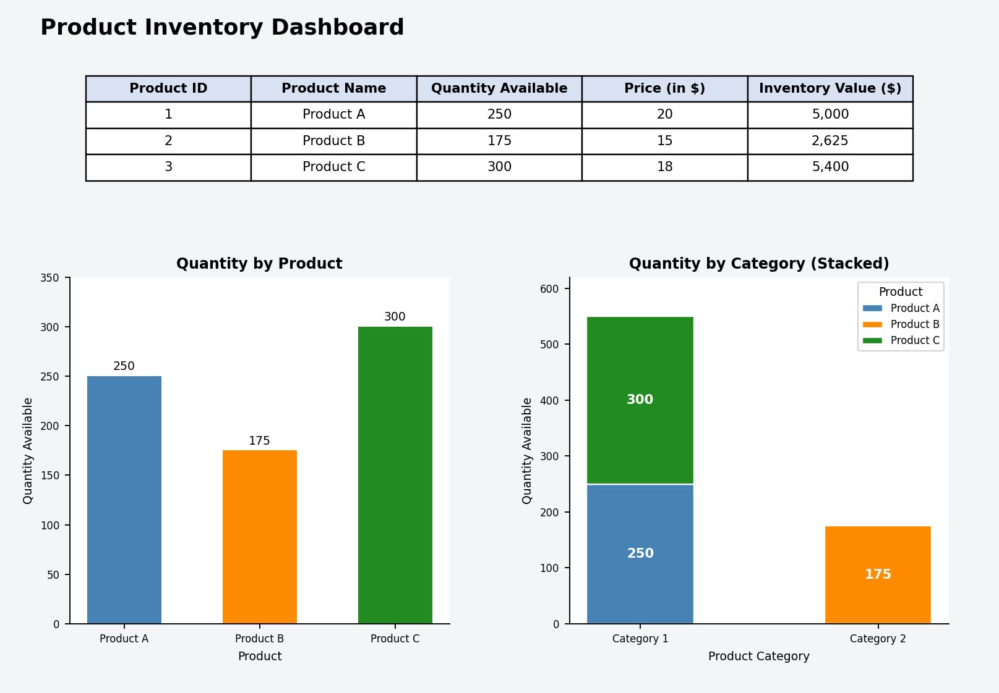
Output 4: Interactive Product Inventory Dashboard (Tableau)
Observation: The dashboard shows the quantity of each product, the quantity by category and the inventory table together. Selecting a product or a category in any view filters the other two.
Procedure
- Define the product inventory data in R as a data frame with Product_ID, Product_Name, Quantity_Available and Price.
- Use barplot() to create the bar chart of the quantity of each product and label the axes and title.
- Add a Category column and use ggplot2 with geom_col() to create the stacked bar chart of quantity by category.
- Calculate the inventory value, display the data with print(), and find the totals with colSums().
- Load the inventory file into Tableau and build the bar chart, stacked bar chart and table worksheets.
- Combine the worksheets in a Tableau dashboard and add filters and actions for interactivity.
RESULT:
The product inventory data was successfully analyzed using a bar chart, a stacked bar chart and an inventory table in R. An interactive Tableau dashboard was also created, combining all three views so that users can explore the inventory by product and by category.
Key Functions and Tools Used
Function / Tool | Purpose
data.frame() | Creates the product inventory table.
barplot() | Creates the bar chart of product quantities.
ggplot() / geom_col() | Creates the stacked bar chart by category.
position_stack() | Places the quantity labels inside the stacked segments.
print() / colSums() | Displays the table and calculates total quantity and value.
Tableau Calculated Field | Calculates the inventory value from quantity and price.
Tableau Dashboard | Combines worksheets with filters and actions.

